
Smart Home Room Control System

December 26, 2025
HTu
Submitted to: Murad Yaghi
Sarah Momani
23110089

- INTRODUCTION:
The quick improvement of the Internet of Things (IoT) has transformed the way physical environments are observed and controlled and managed. IoT facilitates the interconnection of physical devices through the internet letting them to swap data and perform automated actions. Among the several IoT application areas smart home automation has shown as one of the most largely adopted and reasonably impactful areas. Smart home systems aim to improve user comfort and safety energy efficiency,and overall quality of life by authorizing intelligent control of household devices like lighting, appliances, and environmental systems. As residential environments become gradually digitalized, the demand for reliable andflexible and cost effective smart home solutions continues to grow

Even though the growing popularity of smart home technologies there are many existing automation systems that face some limitations that delay their value and large scale adoption. A large number of proposed solutions trust seriously on cloud based architectures where all control and decision making processes performed slightly through internet services. While cloud connectivity gives global accessibility it introduces challenges related to latency and reliability and dependency on continuous network availability. In scenarios where internet connectivity is unstable or even unavailable users may lose the ability to control essential home functions that which reduces system dependability. And some smart home systems are designed for remote control by mobile or web applications often ignoring the importance of local physical control interfaces. The absence of reliable local interface mechanisms can negatively affect usability especially for non technical users or during emergency situations

Local control systems play a critical role in confirming the strength and accessibility of smart home systems. Physical input devices like keypads allow users to interact with the system without requiring network access or external devices. This form improves system reliability and provides fast feedback to users making the system easier and safer to run. many studies highlight that smart home solutions should not depend on solely on remote applications but as an alternative join local control options to confirm continuous operation under many The integration of both local and remote control methods is so essential for developing real and user friendly smart home systems.

From a hardware evaluation the Raspberry Pi has become one of the most used platforms for IoT based home automation systems. The Raspberry Pi proposes a balance between computational capability and flexibility and cost making it fit for prototyping and deploying smart home solutions. Its General Purpose Input Output (GPIO) pins enable direct interfacing with sensors and actuators and input devices like keypads and LED, the availability of high level programming languages like Python simplifies system development and reduces application complexity. Earlier research has confirmed the effectiveness of Raspberry Pi based manners in managing local control tasks while supporting communication with cloud platforms and external devices

Communication protocols are a main component of IoT systems as they discover how devices disagreement information and respond to control commands. Between the various protocols used in IoT environments MQTT and HTTP are two of the most adopted approaches. MQTT is a minor messaging protocol based on the publish subscribe model designed exactly for low bandwidth and supply restricted environments. It allows a real time communication between devices through a middle advisor allowing messages to be effectively distributed to multiple subscribers. Direct to its low operating cost and asynchronous communication model MQTT is well suited for time-sensitive smart home control operations

HTTP follows a traditional client server communication model and is commonly used for web based services and cloud communication. HTTP presents a consistent and reliable method for communicating data between IoT devices and cloud platforms. Even though HTTP is not adjusted for real time control entitled to its request response nature and it stays highly effective for tasks like data logging and system monitoring and historical data analysis. Many IoT cloud platforms depend on on HTTP-based APIs to allow devices to send and take back data securely over the internet. So HTTP remains to play a necessary role in IoT systems that require addition with cloud services

ThingSpeak is one of the most commonly used IoT cloud platforms for data collection and visualization and analysis. It gives a user friendly interface for storing sensor data monitoring system show and visualizing developments over time. ThingSpeak confirms HTTP based communication allowing IoT devices to send data using simple web requests. This makes it suitable for educational and low cost IoT projects where edge of combination and reliability are necessary. Numerous studies have confirmed the efficiency of ThingSpeak in supporting isolated monitoring and cloud based management of IoT systems including smart home and community checking applications

In addition to communication and control the actuator management is a main function of smart home systems. Pulse Width Modulation (PWM) is a widely used technique for limiting actuators like LED and servo motors. PWM allows digital controllers to fake analog output signals by modifying the function cycle of a digital signal. This technique allows efficient control of LED brightness and accurate location of servo motors without complex hardware. PWM-based control has been significantly studied and applied in mechatronic and IoT systems suitable to its simplicity and efficiency and reliability

Even though massive research has been conducted on smart home automation and IoT-based control systems some gaps remain in existing solutions. Many proposed systems focus on either real-time communication protocols or cloud based monitoring platforms but few integrate both methods within a single integrated architecture. Also the role of local physical control interfaces is often underrated although their importance in improving system reliability and usability. There is a clear need for smart home systems that combine local keypad based control and real-time MQTT communication, and cloud based monitoring using HTTP enabled platforms like ThingSpeak. Focusing on this gap can lead to more resilient and flexible and user centrical smart home solutions

To focus these challenges this project proposes the design and implementation of a smart home room control system using Raspberry Pi as the central controller. The system combines local control via a keypad and real time communication using the MQTT protocol and remote monitoring by HTTP communication with the ThingSpeak IoT platform. PWM is working to control LEDs and servo motors allowing efficient and defined device operation. By combining these components into a single system the solution goals to demonstrate a practical low-cost and scalable smart home manner that meets both local and remote user requirements while addressing the limitations identified in existing research.
- Literature Review:
Existing research in Internet of Things based smart home and watching systems introduces a wide range of architectural designs and communication strategies. These studies disagree mainly in the algorithms used for communication and control and data handling which influence system performance and reliability and usability. This section checks the relevant literature and analyzes how the chosen algorithms affect the system behavior.
Aazam et al. (2015) proposed a smart gateway based communication way for Cloud of Things environments. Their system count on a gateway decision-making algorithm that reveals whether data should be controlled locally or forwarded to the cloud. This algorithm lowers unnecessary cloud communication by filtering and managing data at the entry level. so the system experiences lower latency and reduced network blocking and improved consistency for time sensitive operations. However, the proposed approach focuses on a large scale IoT setups and does not include direct physical user interaction like the local control interfaces that which limits its pertinency in built-up smart home environments.
Al-Fuqaha et al. (2015) give a complete survey of IoT allowing technologies and communication protocols instead than implementing a single system. The authors investigated different communication algorithms including the publish/subscribe algorithm used by MQTT and the request/response algorithm used by HTTP. Their findings show that MQTT publish/subscribe model lowers communication overhead and supports faster message delivery that making it suitable for real time control. In differ HTTP request/response model offers higher consistency and simplicity but pioneers latency which affects sensitivity. This study highlights the importance of selecting communication algorithms based on application requirements but it does not give an mixed implementation relating both approaches.
Dinh et al. (2016) introduced a location based interaction algorithm for IoT and cloud integration. Their model appoints services based on device location and cloud availability. This algorithm improves scalability and cloud resource operation by optimizing how devices interact with cloud services. but because the algorithm depends on continuous cloud connectivity system functionality becomes limited during network interferences. This dependence lowers system autonomy and makes it less apt for environments that require reliable local operation.
Nettikadan et al. (2018) implemented a cyclic data gaining and upload algorithm using HTTP communication with the ThingSpeak IoT platform. In approach sensor data is collected and formatted and transmitted to the cloud using HTTP GET requests at fixed intervals. This algorithm confirms reliable data storage and visualization and historical analysis that what making it effective for observing applications. but due to HTTP synchronal nature and voting mechanism the system stands from delayed response times which limits its suitability for the rea ltime actuator control.
Xilir Projects (2023) proposed a cloud based remote control algorithm for smart home automation. In this user commands are proceeded by a web or mobile boundary and executed by devices only after being administered by the cloud server. This approach allows global availability and centralized controlling but informs strong dependency on internet connectivity. As a result the system awareness is affected by network settings and the absence of local control mechanisms decreases reliability during connectivity failures.
MathWorks (2024) documentation added the use of HTTP-based data logging algorithms by ThingSpeak that emphasizing ease of integration and visualization and educational value. While efficient for monitoring the algorithms are not designed for low latency control that reinforcing the need for paired real time communication methods.
the reviewed literature proves that algorithm choice has a direct impact on system performance. Cloud dependent control algorithms enhance accessibility but shrink reliability during network failure. MQTT publish/subscribe algorithms improve awareness but lack built in data visualization. HTTP request/response algorithms gives reliable data storage but present delays. PWM duty-cycle algorithms enable effective actuator control without complex hardware.
Pan and McElhannon (2018) showed a complete survey on the developing roles of edge computing and cloud computing in Internet of Things applications highlighting their mixed impact on system performance and sensitivity. Their study highlights how traditional cloud centrical paradigms face challenges in handling the high volume and velocity of data shaped by IoT devices due to national computation and long distance latency which can reduce real time system behavior. Edge computing in difference allows identified processing closer to the IoT devices that reducing communication wait and preserving bandwidth by preprocessing data before conducting it to cloud servers. The authors also discuss key enabling technologies like Network Function Virtualization (NFV) and Software Defined Networking (SDN) that support scalable delivered processing and offer opportunities for improving IoT system independence and fault tolerance. While the paper focuses on architectural trends and future research directions than implementation specifics it underlines the importance of synergistic edge and cloud integration for achieving low latency scalable, and efficient IoT systems which aligns with the need to balance local control and remote availability in smart home environments.
In our class MQTT HTTPand PWM control algorithms using Raspberry Pi. MQTT was employed using a publish/subscribe algorithm allowing real time message delivery between devices. HTTP was used through GET-based data transmission algorithms to send sensor readings to ThingSpeak for observing and visualization. also (PWM) duty-cycle algorithms were used to control LEDs and servo motors. These algorithms allow digital signals to simulate analog behavior by modifying duty cycles that resulting in smooth and precise and energy efficient actuator control. This work clearly shows how splitting algorithmic roles improves system efficiency and clarity.

Based on these findings, there is a clear research gap in combining many algorithms by a single low cost system. The Existing studies rarely relate local physical control algorithms and real-time MQTT communication or HTTP-based cloud monitoring and PWM actuator control in one combined architecture. Focusing on this gap supports the development of a more reliable and responsive and also user-friendly smart home system that balances local independence with remote accessibility.
- Task2(On-device control): 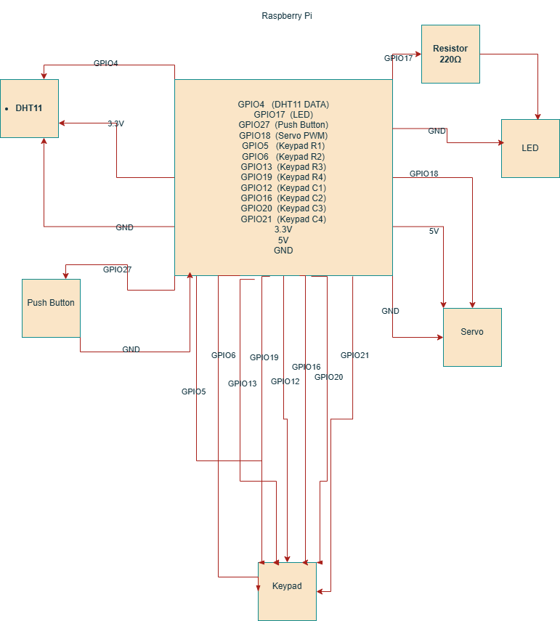

2A) Hardware Assembly and Configuration
The on device control system is built using a Raspberry Pi as the main controller and some minor components to support sensing and user interaction and feeling. The hardware components used in this task a DHT11 temperature and humidity sensor an LED a 4×4 membrane keypad a push button a micro servo motor (SG90). All components are connected using BCM GPIO numbering as required.
The DHT11 sensor is connected using a one wire port with its data pin connected to GPIO4. The LED is connected to GPIO17 and controlled using Pulse Width Modulation (PWM) to allow flexible brightness control. The push button is connected to GPIO27 and configured using an internal pull up resistor to support event driven input recognition.
The keypad involves of four row pins (GPIO5, GPIO6, GPIO13, GPIO19) configured as outputs and four column pins (GPIO12, GPIO16, GPIO20, GPIO21) configured as inputs with pull up resistors. The servo motor is connected to GPIO18 and controlled using PWM at 50 Hz ,an external 5V power supply is used for the servo motor while supporting a common ground with the Raspberry Pi to confirm stable operation.
Environmental Sensing Using DHT11

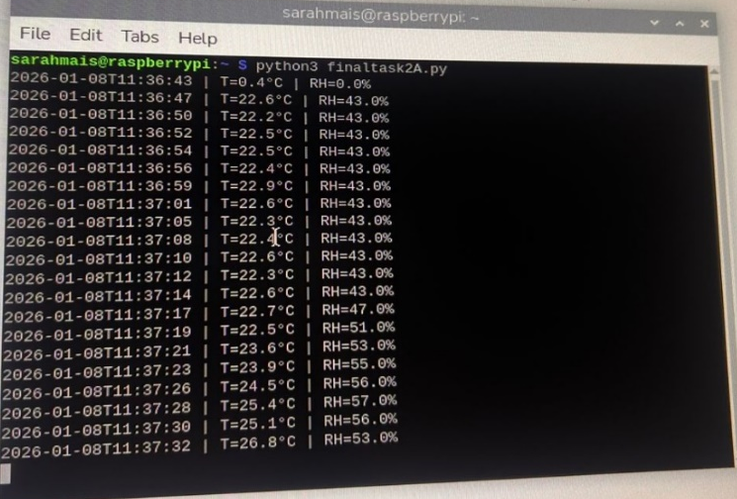

The system constantly monitors environmental conditions using the DHT11 sensor to measure temperature and humidity. The sensor is retrieved using the adafruit_dht library which feeds a reliable interface for one wire communication.
To fulfill with DHT11 timing constraints sensor readings are taken at a fixed period of two seconds. Each reading is printed to the terminal using an ISO 8601 timestamp format followed by the temperature in degrees Celsius and relative humidity in percentage.
Runtime errors caused by sensor timing limitations are handled using exception handling confirming that the system continues operating without crashing. This approach give a stable and periodic monitoring and displays proper on device data gaining.

2B) LED Control via Keypad and Push Button

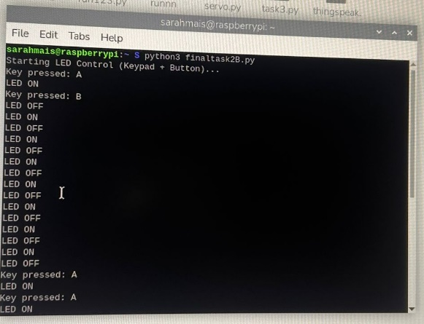

The LED control subsystem supports both polling based input from the keypad and the even driven input from a push button and providing flexible user interaction.
Keypad Control (Polling Scheme)
The keypad is scanned continuously using a polling approach. Each row is sequentially activated and column positions are read to detect key presses. When a key press is detected the system reads the input and acts the corresponding action:
- Pressing ‘A’ turns the LED ON
- Pressing ‘B’ turns the LED OFF
Debouncing is controlled using short software delays to stop repeated detection of the same key press.
Push Button Control (Event Driven Scheme)
The push button is organized using an break based event detection mechanism. When the button is pressed a recall function is automatically triggered without forcing continuous polling. Each button press toggles the LED state between ON and OFF.
This input design explains both polling and event driven approaches highlighting efficient GPIO usage and responsive on device control.
Automated Ventilation Control Using Servo Motor

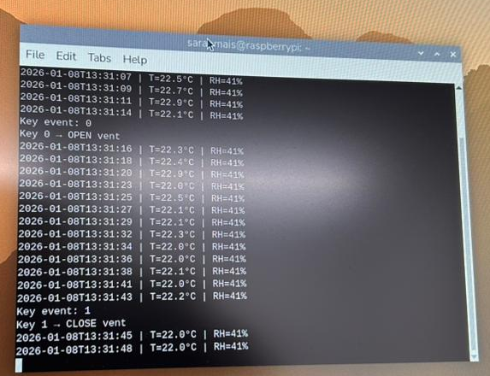
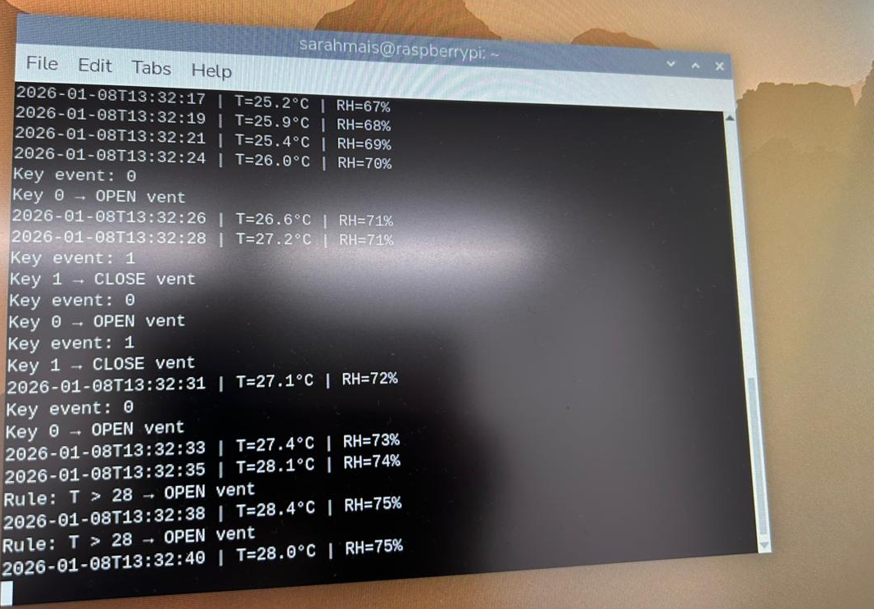
The system realizes an automated ventilation mechanism using an SG90 micro servo motor which controls the opening and closing of a vent or window or door. The servo setup is designed to respond to both manual user input and automatic temperature based rules confirming flexibility and environmental flexibility.
Temperature Based Automatic Control
The system continuously checks the ambient temperature using the DHT11 sensor. Temperature readings are administered at a fixed period of every two seconds, in agreement with the sensor timing limitations. Based on the measured temperature predefined control rules are applied:
- If the temperature exceeds 28 the servo motor goes to 90° opening the vent.
- If the temperature falls below 22 the servo motor rotates to 0 closing the vent.
This automatic control mechanism allows the system to respond enthusiastically to environmental changes without requiring user involvement improving comfort and ventilation efficiency.
Keypad Based Manual Control (Event-Driven)
In addition to automatic operation the system allows instructions override through a 4×4 keypad. The keypad operates using an event driven detection scheme confirming that each key press is processed only once and inhibiting repeated or unintended servo movements.
The manual control rules are defined as follows:
- Pressing ‘0’ rotates the servo to 90 opening the vent.
- Pressing ‘1’ rotates the servo to 0 closing the vent.
This double control approach allows users to directly control ventilation when needed whatever of the current temperature conditions.
Servo Control Method
Servo position is achieved using (PWM). By adjusting the PWM duty cycle the system can control the servo angular situation while minimizing power utilization and mechanical stress. This method confirms smooth and reliable operation of the ventilation mechanism.
System Behavior Verification
Station outputs confirm correct system behavior:
- Normal temperature readings with ISO timestamps
- Keypad events causing instant servo movement
- Automatic vent opening when the temperature is above 28
- Automatic vent closing when the temperature drops below 22

System Reliability and Local Autonomy
The system is designed to run fully on the Raspberry Pi without relying on an active internet connection.and all control logic including environmental sensing using the DHT11 sensor and LED control over the keypad and push button and servo motor operation for ventilation is treated locally on the device. User inputs are handled through GPIO interactions and actuator movement is managed using PWM signals made by the Raspberry Pi.
By completing all detection and control tasks on the device itself the system stay fully functional even during network outages or unstable connectivity. This local autonomy confirms immediate system response to user actions and environmental changes without delays caused by cloud communication. so, the system offers higher consistency and faster reaction time and improved user confidence markedly in situations where continuous connectivity cannot be assured or rapid manual interference is required.
Task 3

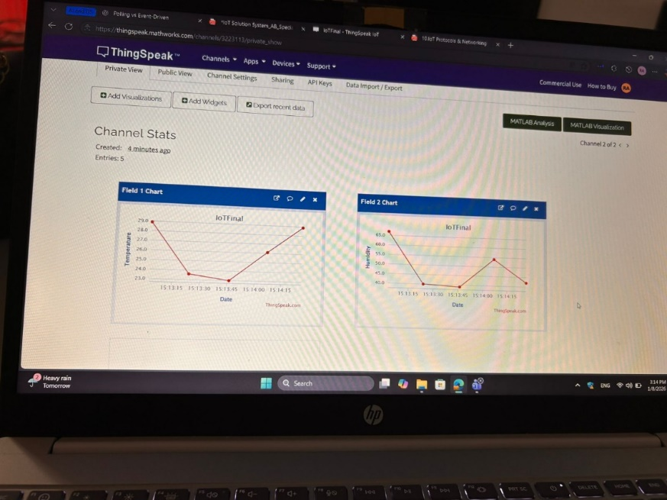

Raspberry Pi reads temperature and humidity from the DHT11 sensor and uploads them to a ThingSpeak channel using HTTP requests every 20 seconds.
Why HTTP + ThingSpeak
ThingSpeak supports writing data to a channel using simple HTTP requests to the update endpoint and where every field maps to a measurement (field1, field2) using HTTP GET requests with API keys to write data into ThingSpeak fields (field1, field2)
- Read sensor data
- Format a timesmap
- Build the HTTP para
- Send the HTTP get request
- Validate request
ThingSpeak “Channel Stats” page shows Field 1 (Temperature) and Field 2 (Humidity) graphs updating over time that confirming successful uploads and correct field mapping.

IoT Protocol Comparison
IoT systems depend on communication protocols to allow data exchange between devices and gateways and cloud platforms. The choice of protocol affects system efficiency and scalability and reliability and suitability for many applications.

HTTP (Hypertext Transfer Protocol)
HTTP follows a client server and request response communication model. In IoT systems the client the (IoT device) sends a request to a server the (cloud platform and the server responds with an response or requested data. This communication style is deported meaning each request is independent and contains all necessary information.
From an efficiency scale HTTP introduces higher above because of its rambling headers and the need to found a request for each data transfer. This makes it less suitable for high frequency and real time communication between controlled devices. However, HTTP offers interoperability and reliability and ease of combination as it is supported by web services and cloud platforms.
HTTP is primarily used for cloud communication and data logging rather than real-time control. The ThingSpeak IoT platform is clearly designed to accept data through HTTP based REST APIs making HTTP the most suitable protocol for telemetry upload and visualization. This aligns with the method adopted where temperature and humidity data are continually uploaded to ThingSpeak using HTTP requests

MQTT (Message Queuing Telemetry Transport)
MQTT is a lightweight publish and subscribe protocol designed for IoT environments. Unlike HTTP MQTT uncouples senders (publishers) and receivers (subscribers) through a broker allowing asynchronous and event driven communication. Devices publish messages to topics and subscribers get updates only for topics they are involved in.
MQTT is efficient in conditions of bandwidth and processing making it well suited for resource constrained devices and a real time communication. MQTT reduces network traffic and latency compared to HTTP specifically when repeated updates or control commands are required
In smart home automation research MQTT is used for real time control and management and emergency signaling like safety alerts or system wide commands. This is stable with the design adopted in this project where MQTT is used to implement a network wide Safe Mode and to collect environmental data that causes immediate system responses. The publish/subscribe model allows many points to react at once to the same message which is necessary for synchronized smart home behavior

Comparison Between HTTP and MQTT
HTTP and MQTT act different but balancing roles in IoT systems reasonably than comparing ones. HTTP excels in scenarios that need cloud addition and data storage and visualization, while MQTT is better for real time and low latency communication between devices.
Smart home automation examines highlight that systems trusting solely on HTTP often experience from delayed response times and extreme network overhead when used for control functions, Equally systems that depend on MQTT may want efficient mechanisms for long term data storage and visualization. As a result various researchers recommend a hybrid communication design where MQTT is used for real time control and HTTP is used for cloud communication and monitoring.
This hybrid approach is clearly supported by the reviewed articles and is showed in the architecture of the proposed system which uses MQTT for management and control and HTTP for telemetry upload to ThingSpeak.

Other IoT Protocols
- CoAP (Constrained Application Protocol) assumes a REST-like model similar to HTTP but is improved for limited devices operates over UDP. It is suitable for low power sensor networks but is less supported by cloud platforms compared to HTTP.
- AMQP (Advanced Message Queuing Protocol) gives reliable message queue up and routing but proposes higher complexity and overhead making it more suitable for activity systems rather than lightweight smart home environments.
- DDS (Data Distribution Service) is designed for high performance and real time systems like industrial automation and robotics. While highly efficient it is more complex than required for small scale smart home applications.

Justification of Protocol Choice
Based on the lecture material and reviewed research the protocol selection in this project is :
. HTTP is used for remote telemetry and cloud visualization because it is supported by ThingSpeak and gives a simple and reliable method for continuing data upload.
- MQTT is used for real time matching and control because of its lightweight publish/subscribe model and low latency and suitability for event driven smart home strategies.
the limitations identified in existing smart home systems, where relay on a single protocol often results in lowered performance or flexibility. By mixing both protocols the proposed system gets improved efficiency and scalability and reliability

Task 4
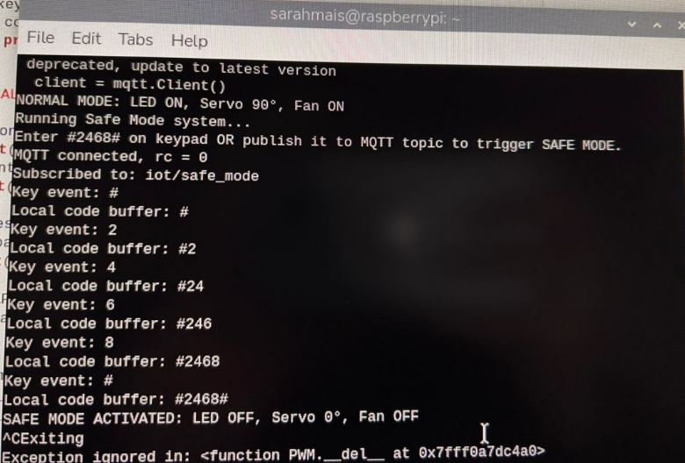

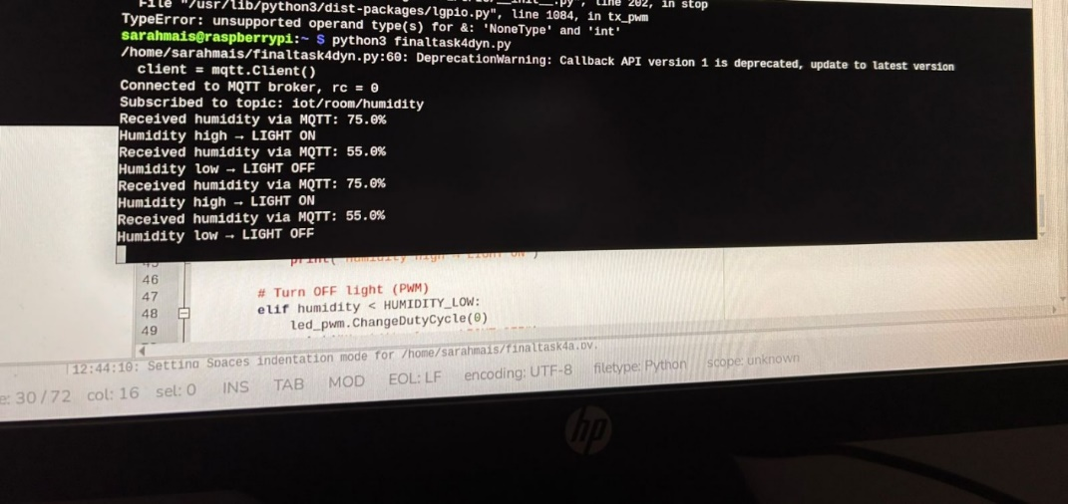

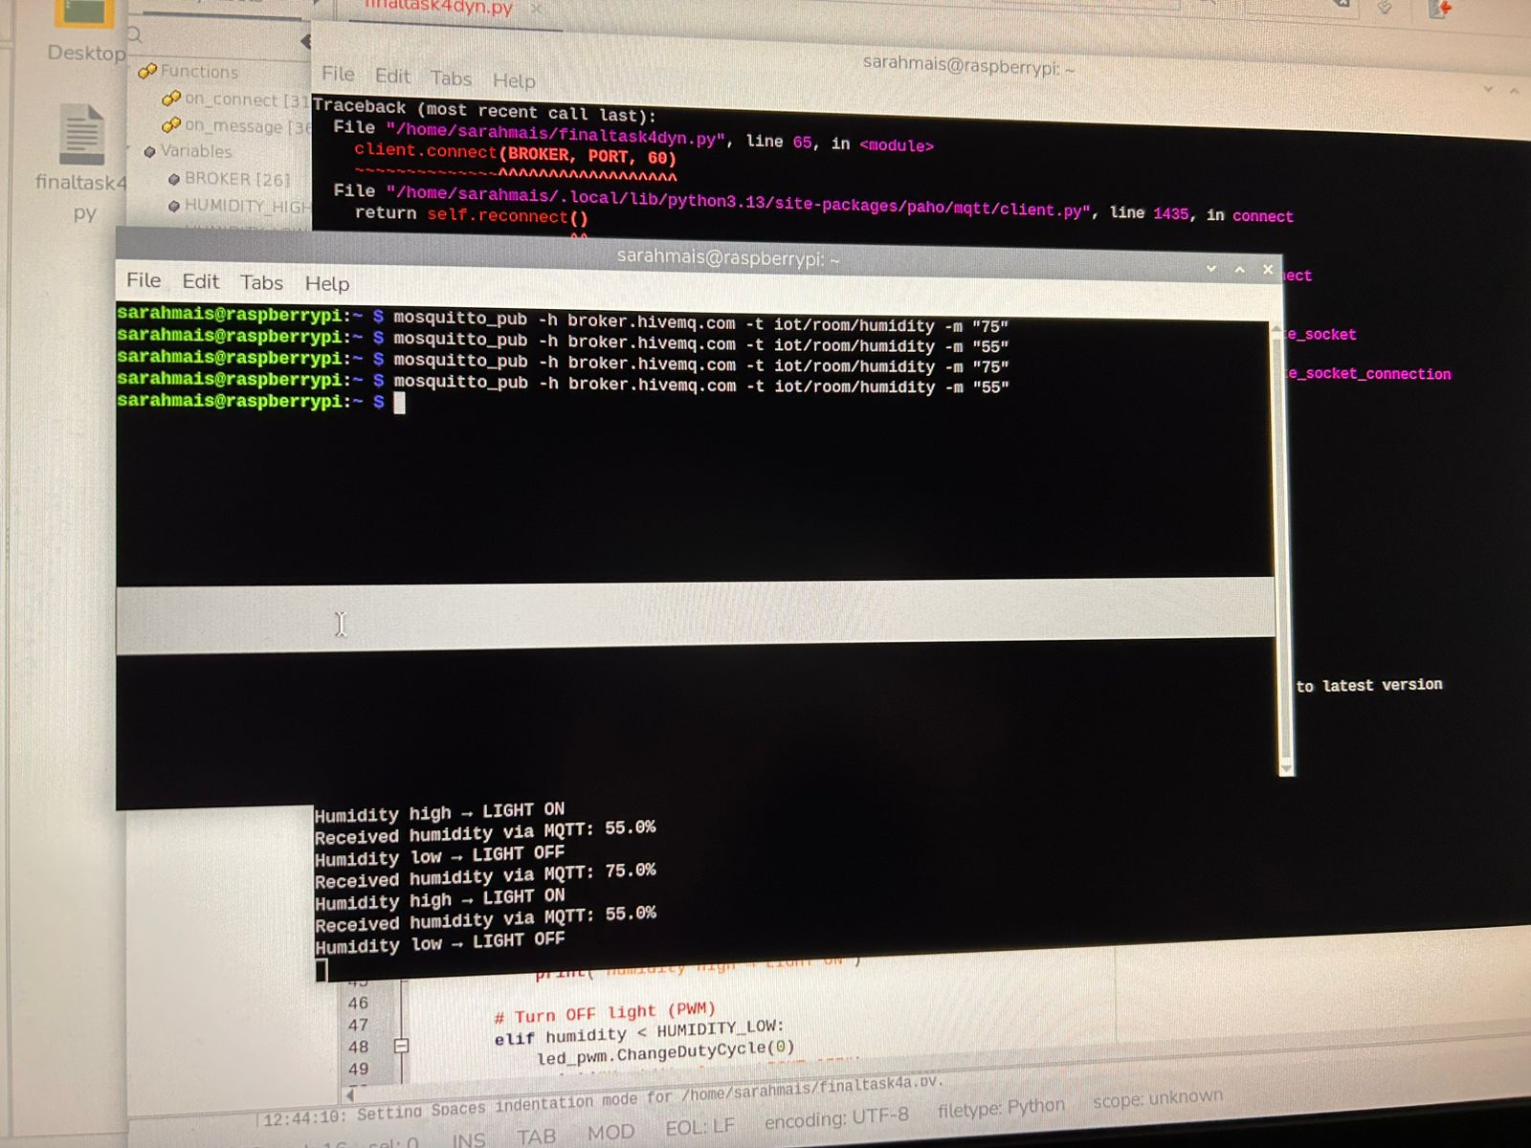

4.1 Network-Wide Safe Mode Coordination Using MQTT
The system employs a network wide Safe Mode system that allows emergency actions to be activated locally by a keypad or remotely via MQTT communication. A safety code #2468#, is predefined and shared across the system to confirm consistent behavior across all nodes.
When the code is written locally the keypad scanning logic collects the pressed keys in a memory and checks whether the entered sequence matches the Safe Mode code. Once detected the Safe Mode routine is requested. In parallel the system subscribes to a predefined MQTT topic given to safety control. If a message holding the same safety code is received by MQTT the system reads it as a remote Safe Mode request.
To confirm safe implementation the system does not implement hardware actions directly inside the MQTT callback. a Safe Mode flag is set and handled by the main control loop. This prevents concurrence issues and ensures stable GPIO operation.
Upon activation of Safe Mode
- The LED is turned OFF
- The servo motor rotates to 0°
- The fan is stopped
This proves synchronized system wide behavior anyway of whether the Safe Mode command makes from local input or remote MQTT messaging. The terminal outputs clearly show successful detection of the safety code and correct execution of Safe Mode actions.

4.2 Operation Without Internet Connectivity
Reliable IoT systems must preserve main functionality even when internet connectivity is lost. In this system internet failure affects only external MQTT communication while all local control and decision making processes continue to control on the Raspberry Pi.
When internet connectivity unavailable the MQTT client can no longer communicate with public MQTT brokers (like ThingSpeak). To handle this the system depend on local processing and control techniques where all critical logic is finished directly on the device. Environmental sensing and keypad input processing, Safe Mode detection with LED control and servo motor actuation are done locally using GPIO interruptions voting mechanisms and PWM signals, confirming continuous operation regardless of network availability.
To conserve MQTT based management during internet outages the system supports the use of a local MQTT broker running on the Raspberry Pi itself and configured using the localhost interface. This technique allows local publish/subscribe communication that allowing MQTT publishers and subscribers within the same local network to continue exchanging messages without depending on external internet access. This method follows a gateway based and edge computing architecture where control logic is shifted closer to the devices to improve independence and reduce latency and increase system flexibility.
also the system tools an automatic reconnection mechanism within the MQTT client. When internet connectivity is reinstated the client continually attempts to reconnect to the external broker and flawlessly restarts normal cloud based communication without involving manual intervention. This reconnection strategy confirms smooth change between offline and online modes.
By linking local edge processing on-device MQTT brokering and event-driven GPIO control and automatic broker reconnection, the system does high consistency and fault tolerance. These techniques confirm continuous system behavior fast reaction times and faithful operation during network interruptions which is fundamental for smart home environments where safety and availability are critical.

4.3 Dynamic System Reaction to Environmental Data via MQTT
In count to safety coordination the system dynamically responds to environmental data received through MQTT channels likehumidity information.
The system subscribes to a given MQTT topic that has humidity readings. When a new message arrives the MQTT callback function translates the message load and switches it into a numerical humidity value. This value is then given to the decision making logic.
The lighting control rules
- If the received humidity value beats a predefined high threshold the system turns the LED ON
- If the humidity value falls below a predefined low threshold the system turns the LED OFF

4.4 MQTT Message Interpretation and Decision-Making Logic
The system uses an event driven decision making model enabled by MQTT’ publish/subscribe architecture. Rather than continuously polling for data the system reacts only when relevant MQTT messages arrive.
Every incoming MQTT message set off a callback function where the message topic and load are analyzed the system decides whether the message corresponds to:
- Safe Mode activation
- humidity-based lighting control
step-by-step interpretation flow
- MQTT message arrives at the broker and is delivered to the Raspberry Pi
Because the Raspberry Pi is subscribed to identifiable topics the broker forwards any new message published on these topics to the device.
- The MQTT client triggers the callback function (on message) automatically
rather than polling the program reacts only when a message is received. The callback is the access point for reading the incoming data.
- The system reads the message metadata (Topic) to identify the message type
The topic is checked first because it shows the kind of information:
- If the topic belongs to Safe Mode the message is treated as an emergency command.
- If the topic belongs to environmental data the message is treated as a sensor reading used for automation.
- The system decodes the payload into readable data
- The system validates the payload format before making decisions
  - For Safe Modethe payload is checked to verify it matches the universal code #2468#.
  - For humidity, the payload is changed into a numeric value and If conversion the message is ignored to avoid wrong actions.
- Decision logic is applied based on message type
  - Safe Mode decision:
If the decoded payload equals the Safe Mode code or it has it the system sets a Safe Mode request flag.
  - Humidity decision:
The received humidity value is compared with predefined thresholds
- The system executes the corresponding hardware action safely
  - For Safe Mode: LED OFF servo to 0 fan OFF.
  - For humidity lighting: LED ON/OFF (or PWM duty cycle change).
In safe operation hardware actions are performed in the main loop using flags than inside the callback confirming stable GPIO behavior.
- The system logs the decision for debugging and verification
The terminal prints:
  - Received topic and payload
  - Interpreted value (humidity )
  - The chosen action (LED ON/OFF or Safe Mode triggered)

For safety messages the load is related against the predefined Safe Mode code. For environmental messages numerical judgement is applied using predefined thresholds. This structured message reading confirms fast response and low processing overhead and scalable coordination between devices.
This approach shows how MQTT supports uncoupled communication allowing sensors and controllers and actuators to co-operate without direct dependency on each other.

References :
- Aazam, M., St-Hilaire, M., Lung, C.-H. and Lambadaris, I. (2015) ‘Smart gateway based communication for cloud of things’, IEEE International Conference on Cloud Computing Technology and Science, Vancouver, Canada, pp. 406–413. Available at:
https://www.researchgate.net/profile/Mohammad-Aazam/publication/269303095_Smart_gateway_based_communication_for_cloud_of_things/
- Al-Fuqaha, A., Guizani, M., Mohammadi, M., Aledhari, M. and Ayyash, M. (2015) ‘Internet of Things: A survey on enabling technologies, protocols, and applications’, IEEE Communications Surveys & Tutorials, 17(4), pp. 2347–2376. Available at:
https://ieeexplore.ieee.org/document/7123563
- Dinh, T.H., Kim, Y. and Lee, J. (2016) ‘A location-based interactive model of Internet of Things and cloud (IoT-Cloud)’, Procedia Computer Science, 80, pp. 189–197. Available at:
https://www.sciencedirect.com/science/article/pii/S1877050916001745
- MathWorks (2024) ThingSpeak IoT Platform Documentation. Available at:
https://thingspeak.com/
- Nettikadan, D., Prasad, A. and Varghese, J. (2018) ‘Smart community monitoring system using ThingSpeak IoT platform’, International Journal of Engineering Research & Technology, 7(6), pp. 1–5. Available at:
https://www.researchgate.net/profile/David-Nettikadan-2/publication/328367978_Smart_Community_Monitoring_System_using_Thingspeak_IoT_Plaform/
- Xilir Projects (2023) A smart home automation technique. Available at:
https://xilirprojects.com/wp-content/uploads/2023/01/7.-A-Smart-Home-Automation-Technique.pdf
- Yaghi, M. and Ghanem, I. (2024) IoT Protocols & Networking: MQTT and HTTP with ThingSpeak (Lecture Slides). Al-Hussein Technical University.
- Pan, J. and McElhannon, J. (2018) Future Edge Cloud and Edge Computing for Internet of Things Applications. IEEE Internet of Things Journal, 5(2), pp. 439–449. Available at: https://www.researchgate.net/publication/320723809_Future_Edge_Cloud_and_Edge_Computing_for_Internet_of_Things_Applications (Accessed: 17 January 2026).
- Mosquitto (2024) Eclipse Mosquitto – An Open Source MQTT Broker. Available at:
https://mosquitto.org/documentation/
(Accessed: 7January 2026).
- Raspberry Pi Foundation (2024) Raspberry Pi Documentation: GPIO and Hardware Interfaces. Available at:
https://www.raspberrypi.com/documentation/computers/os.html
(Accessed: 7 January 2026).

